Feature image: The Best Men’s Luxury Watches Under $10,000

Title: Shop the best men’s luxury watches under $10K today
Focus Keyword: Men’s Luxury Watches
Secondary Keyword:
luxury men watch
best luxury timepieces
luxury timepiece brands

Internal link:
best luxury watch brands: https://swissiceco.com/
Swiss Luxury timepieces: https://swissiceco.com/pages/watches

Also write Meta Description.

Meta Description:
Shop authenticated pre-owned men’s luxury watches under $10K confidently. Swiss Ice Co’s expertise ensures value, verified condition & warranty.

Shop the best men’s luxury watches under $10K today H1
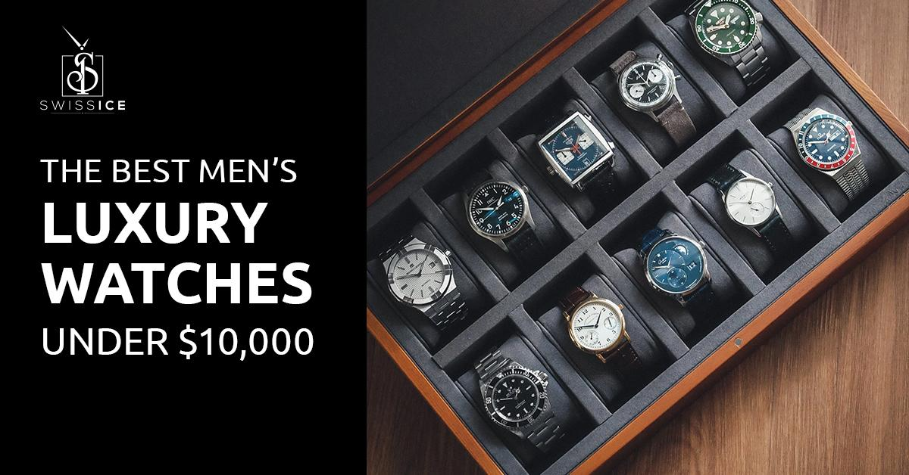
You know that moment when light catches a watch dial just right? When the weight feel perfect on your wrist? That’s not about price tags. It’s about owning a piece of horology that resonates with you. At Swiss Ice Co, we’ve spent many years connecting collectors with pre-owned men’s luxury watches that deliver this sensation, without demanding a fortune. Forget "affordable" meaning "compromise." Our collection holds Cartier Tanks, Omega Speedmasters, and Rolex Oysters priced under $10,000, each authenticated to stand the test of time. Let’s rewrite what "accessible luxury" means together.

Why Pre-Owned Wins: Insights From Swiss Ice Co Experts H2
Let's address the elephant in the room. Some hesitate about pre-owned. We get it. The idea of buying someone else's watch might raise questions. But here's what we've learned after years in this business. Pre-owned isn't second best. It's often the smartest path to genuine luxury.

Lower Value Depreciation H3
Think about cars. A meticulously maintained, low-mileage pre-owned luxury car offers incredible value over a brand-new new. The same principle applies powerfully to fine watches. The most significant depreciation hit happens the moment a new watch leaves the shop. By choosing pre-owned, you instantly sidestep that loss. Your money goes much further, allowing you to acquire a watch that might have been out of reach new.

Link to History and Rarity H3
Beyond value, pre-owned opens doors to history and rarity. Many iconic models are discontinued. Finding them new is impossible. The pre-owned market is where these treasures live. You might find a specific dial variation, a beloved reference from a past era, or a model that simply speaks to your personal history. That’s a connection a brand-new display case often can't offer. We see clients light up when they find that exact watch they remember admiring years ago, now available and affordable.

Quality Without Compromise H3
Concerns about condition and authenticity are valid. This is precisely where partnering with a specialist like Swiss Ice Co makes all the difference. Every single luxury timepiece brands watch we offer undergoes a multi-point inspection by our veteran watchmakers. We look beyond the surface, examining the movement, case integrity, dial originality, and bracelet wear. We verify authenticity with the precision born of handling thousands of watches. We’re not a faceless online marketplace. We are specialists who stake our reputation on every piece we sell. That peace of mind is invaluable.

Exceptional Men’s Luxury Watches Under $10K: Our Curated Picks H2
Now, the exciting part. What incredible luxury men watches can you actually find pre-owned under $10,000? Plenty. Here are some standout examples from the best luxury watch brands, based on what we consistently see delivering incredible value, style, and reliability in our inventory:

Omega Seamaster Professional H3
A true icon. Favorite watch of choice (since the 90s). The current generation, especially models from the early 2010s onwards, offers incredible value pre-owned. You get a robust Co-Axial Master Chronometer movement (anti-magnetic and highly accurate), stunning wave dial, ceramic bezel, and 300m water resistance. Expect to find excellent examples well under $5,000, sometimes even dipping near $4,000. It’s hard to beat this combination of heritage, tech, and style.

Rolex Oyster Perpetual H3
The essence of Rolex is simplicity and quality. While prices for sports models have soared, the classic Oyster Perpetual remains a superb entry point to the crown. Pre-owned examples, particularly the slightly older 39mm models or the vibrant dial 36/41mm versions, frequently trade comfortably under $10,000. You get the legendary Rolex build quality, reliability, and that timeless aesthetic. It’s pure, understated luxury.

Tudor Black Bay H3
Rolex's sister brand has carved its own formidable identity. The Black Bay line, inspired by vintage Tudor dive watches, is a powerhouse. Models like the Black Bay 41 with the in-house MT5602 movement offer incredible build

IWC Portofino Automatic H3
The Portofino’s Mediterranean simplicity transcends fleeting trends. Pre-owned 40mm with IWC’s robust 35111 movement regularly surfaces between $3,200-$4,800. We appreciate its versatility. You can pair it equally well with linen shirts or business attire. Unlike many dress watches, the 30-bar water resistance makes it surprisingly resilient. When servicing these, we consistently note minimal wear to key components, a testament to IWC’s engineering.

Jaeger-LeCoultre Master H3
JLC’s "watchmaker’s watchmaker" reputation becomes accessible pre-owned. The Master Control Date delivers horological gravitas under $10,000, often near $8,500 for 2020. It's a 39mm case that houses the ultra-reliable Caliber 899/1 with 70-hour power reserve and Geneva wave finishing. The sector dial and cathedral hands offer vintage charm without fragility. During authentication, we inspect the distinctive "1000 Hours Control" seal on casebacks, which only a few Swiss luxury timepieces at this price point offer such technical pedigree.

Why Swiss Ice Co is Your Ideal Partner in Pre-Owned Men’s Luxury Watches? H2
Choosing where to buy your men’s luxury watch is as crucial as choosing the watch itself. Here’s what sets Swiss Ice Co apart, grounded in our daily operations:

Depth of Inventory, Selected by Experts H3
We don’t just list watches, but we make sure every piece is authentic. Our buyers leverage decades of combined market knowledge to source pieces offering genuine value and desirability under $10K. You’ll find diversity in our collection. From iconic sports models to elegant dress pieces, you will find every luxury watch in our collection. Every single watch in our collection meets our stringent entry criteria. We track market trends daily, ensuring our offerings reflect real value.

Transparency You Can See H3
Generic stock photos are useless for pre-owned. Our commitment is absolute. You will see dozens of high-resolution, unedited photos showing every single angle and imperfection of the actual watch you receive. Our condition descriptions are totally honest, written by people who handle the watch, not an algorithm. You see exactly what we see.

Provenance & History Focus H3
Where possible, we provide background. Was it a single-owner watch? Serviced recently? Come with the original box and papers? We gather and share every detail we have. This context adds depth and confidence to your purchase.

White-Glove Sourcing Assistance H3
Overwhelmed by choice? Tell us what you love, whether it be a specific model, a style, a feature, your wrist size, or your budget. Our experienced team uses deep knowledge of current and past inventory, plus market availability, to source potential matches just for you. We’ve found discontinued grails for clients they thought were impossible. This personalized approach stems from countless successful client consultations.

Post-Purchase Partnership H3
Our relationship doesn’t end at delivery. Need advice on servicing? Curious about strap options? Question about the movement? We’re here. We provide documentation outlining service recommendations based on the watch’s age and our initial inspection. We leverage our network to recommend qualified service centers globally.

Secure & Streamlined Transaction H3
We utilize industry-leading secure payment gateways. Your funds are protected until you confirm acceptance. International shipping is handled expertly with full insurance and transparent tracking. We manage customs complexities for a smooth delivery. Returns are straightforward within our clearly stated policy period, though our detailed listings and photos make returns rare.

Community & Knowledge Sharing H3
We believe an informed buyer is our best customer. Beyond listings, we actively share insights on market trends, collecting nuances, brand histories, and maintenance tips through our blog and client communications. Our staff's knowledge about luxury watches has helped handle tens of thousands of the best luxury timepieces.

Final Thoughts: H3
The journey to owning an exceptional men’s luxury watch under $10,000 is clearer now. You understand the compelling value proposition of pre-owned. You know the key brands and models offering incredible quality and prestige within this budget. You recognize the critical importance of authenticity, condition, transparency, and, above all, choosing the right expert partner.
At Swiss Ice Co, we’ve dedicated ourselves to redefining the pre-owned luxury watch experience. We combine the selectivity and knowledge of seasoned collectors with the rigorous processes and guarantees of a professional institution. We treat every watch with respect and every client with personalized attention. We don’t just sell ordinary watches. We help you acquire a piece of horological artistry and history that fits your life.
GMB Description
Swiss Ice Co is an expert in authenticated pre-owned men’s luxury watches under $10,000. With many years of specialized experience, we physically inspect every Rolex, Omega, Cartier, and Tudor timepiece using forensic-level authentication protocols. Our shop processes include movement analysis under magnification, case integrity checks, and humidity testing. We offer transparent condition grading with 50+ high-resolution photos per watch, detailed service history documentation, and a warranty. Visit our store or browse online for exceptional value on iconic models like the Omega Seamaster 300M, Rolex Oyster Perpetual, and Tudor Black Bay. All of which are priced 25-40% below retail. Our sourcing service finds discontinued grail watches while our consignment program provides fair market valuations. Trusted by collectors globally for rigorous verification against counterfeits and stolen databases. Acquire investment-grade Swiss luxury timepieces with confidence at Swiss Ice Co.

